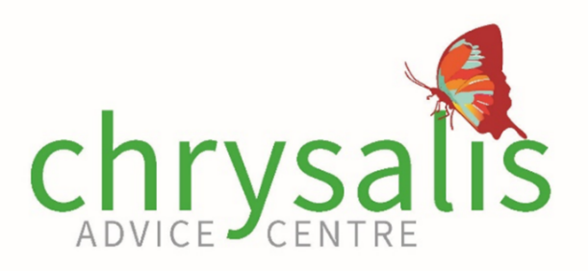
Please fill ALL information below and email it to chrysalis@advancecharity.org.uk
Appointments are not confirmed until you receive a confirmation email.
Name of referrer

Agency

Referrer’s phone number

Referrer’s email address

Name of client

Do they have children?
Safe contact details
(email/mobile number etc)

Preferred method of contact  (Highlight as appropriate) | Telephone call WhatsApp video call  Zoom call Facetime call  Other (please specify):
Please specify if it is safe to leave a message i.e does their partner check their voicemails- does their partner work during the day, do they live together or are they separated

Specific needs of victim/survivor
(e.g. does the victim/survivor need an interpreter, supports needs around drug or alcohol misuse, mental health or disability?)

Professional requested:

Agency | Support requested  (i.e., benefits advice, legal advice etc) | 1st Appointment time requested | 2nd Appointment time requested
Brent Housing  (support with housing application, information & advice around housing) |  | Choose an item. | Choose an item.
Bowling & co solicitors  (legal advice around domestic abuse, court orders, advice on divorce |  | Choose an item. | Choose an item.
Asian women’s resource centre  (Domestic abuse support for women ages 16+, harmful practices (honour-based violence, FGM) |  | Choose an item. | Choose an item.
If first slot is not available, then every effort will be made to accommodate for second slot requested.

